ASSIGNMENT 2

Assignment 2: Design and develop a website for various clubs in Vishwakarma Institute of Technology using HTML and CSS Box Structure and various elements.

HOME PAGE

<!DOCTYPE html>

<html lang="en">

<head>

<meta charset="UTF-8">

<meta name="viewport" content="width=device-width, initial-scale=1.0">

<title>Aaroha</title>

<style>

* {

margin: 0;

padding: 0;

box-sizing: border-box;

}

body {

font-family: Arial, sans-serif;

line-height: 1.6;

background-color: #f4f4f4;

color: #333;

}

header {

background-color: #0a0e49;

color: #fff;

text-align: center;

padding: 20px 0;

box-shadow: 0 4px 6px rgba(0, 0, 0, 0.1);

}

header h1 {

font-size: 2.5rem;

margin-bottom: 10px;

}

header img {

border-radius: 50%;

margin-right: 20px;

}

nav {

margin-top: 15px;

}

nav a {

color: #fff;

text-decoration: none;

margin: 0 15px;

font-size: 16px;

padding: 10px 20px;

display: inline-block;

border-radius: 4px;

transition: background-color 0.3s ease;

}

nav a:hover {

background-color: #6327c4;

}

.container {

width: 80%;

margin: auto;

overflow: hidden;

padding-top: 30px;

}

.content {

background-color: #fff;

padding: 20px;

margin-bottom: 30px;

border-radius: 8px;

box-shadow: 0 4px 8px rgba(0, 0, 0, 0.1);

}

.content img {

width: 100%;

max-width: 300px;

margin: 10px;

display: inline-block;

border-radius: 8px;

}

footer {

background-color: #0a0e49;

color: #fff;

text-align: center;

padding: 15px 0;

position: static;

bottom: 0;

width: 100%;

font-size: 14px;

box-shadow: 0 -4px 6px rgba(0, 0, 0, 0.1);

}

a {

color: #1493e2;

text-decoration: none;

}

a:hover {

text-decoration: underline;

color: #4532ad;

}

.ending .content {

margin-bottom: 20px;

}

.ending h3 {

margin-bottom: 10px;

font-size: 1.8rem;

color: #35424a;

}

.ending p {

font-size: 1rem;

color: #333;

margin-bottom: 10px;

}

.ending a {

font-weight: bold;

}

@media (max-width: 768px) {

header h1 {

font-size: 2rem;

}

.container {

width: 90%;

}

nav a {

display: block;

margin: 10px 0;

}

.content img {

max-width: 100%;

margin: 10px 0;

}

footer {

font-size: 12px;

}

}

</style>

</head>

<body>

<header>

<h1><img src="https://encrypted-tbn0.gstatic.com/images?q=tbn:ANd9GcRQ_VdLkRJ7tND6d7Q0t0uarDADzCgHAO5u1Q&s" alt="This is club logo" width="200px" height="200px" > Welcome to the aaroha Club</h1>

<nav>

<a href="http://127.0.0.1:5500/web%20Development/web%20page%20assignment.html">Home</a>

<a href="#about">About Us</a>

<a href="#events">Events</a>

<a href="#join">Join Us</a>

<a href="#contact">Contact</a>

</nav>

</header>

<div class="container">

<div class="content" id="info">

<h2>Aaroha - Music Club</h2>

<p>Music encompasses every aspect of life. Various enthusiasts, performers, students who thought of pursuing a carrer in music need a chance to present themselves, more so, a platform where someone can appreciate their talents</p>

<img src="https://encrypted-tbn0.gstatic.com/images?q=tbn:ANd9GcRQ_VdLkRJ7tND6d7Q0t0uarDADzCgHAO5u1Q&s" alt="this is a image of aaroha" width="33%" height="300px">

<img src="https://i.ytimg.com/vi/vZdWJ_jIKsI/hqdefault.jpg" alt="" width="33%" height="300px">

<img src="https://i.ytimg.com/vi/OtHNsC8fKkY/hqdefault.jpg" alt="" width="33%" height="300px">

</div>

<div class="content" id="about">

<h2>About Us</h2>

<p>We are a community of music lovers dedicated to the art of singing. Whether you are a beginner or an experienced singer,<br> our club offers a supportive environment for everyone to improve their skills and enjoy music.</p>

<iframe src="https://www.youtube.com/embed/PLvWw88efz4?si=8h6gn46Ce5sbl9LI" width="560" height="315" title="YouTube video player" frameborder="0" accelerometer; autoplay; clipboard-write; encrypted-media; gyroscope; picture-in-picture; web-share" referrerpolicy="strict-origin-when-cross-origin" allowfullscreen></iframe>

<br>

<ul>

<li>Aaroha is enthusiasts club </li>

<li>About Us: <a href="http://127.0.0.1:5500/web%20Development/Assignment%202/Web%20Developmet%20About%20us.html"> Know more</a></li>

</ul>

</div>

<div class="content" id="events">

<h2>Upcoming Events</h2>

<ul>

<li>Weekly Singing Practice - Every Tuesday at 6 PM</li>

<li>Annual Singing Competition - March 15</li>

<li>Guest Vocal Coach Workshop - April 20</li>

<li>More Events info: <a href="http://127.0.0.1:5500/web%20Development/Web%20Development%20assignmenet%20events.html">More Events</a></li>

</ul>

</div>

</div>

<div class="ending">

<div class="content" id="join">

<h3>Join Us</h3>

<p>If you love singing and want to improve your skills, we invite you to join our club! Fill out the <a href="#contact">contact form</a> below to get started.</p>

</div>

<div class="content" id="contact">

<h3>Contact Us</h3>

<ul>

<li><p>If you have any questions or would like more information, please reach out!</p></li>

<li><p>Email: <a href="mailto:info@aaroha.com">info@singingclub.com</a></p></li>

<li><p>Insta: <a href="https://www.instagram.com/vit_aaroh/" target="_blank"> Aaroha(vit pune)</a></p></li>

<li>Registration form: <a href="http://127.0.0.1:5500/web%20Development/Web%20Developmet%20About%20us.html"> Know more</a></li>

</ul>

</div>

</div>

<footer>

<p>&copy; 2024 Singing Club. All rights reserved. || validated by RK</p>

</footer>

</body>

</html>

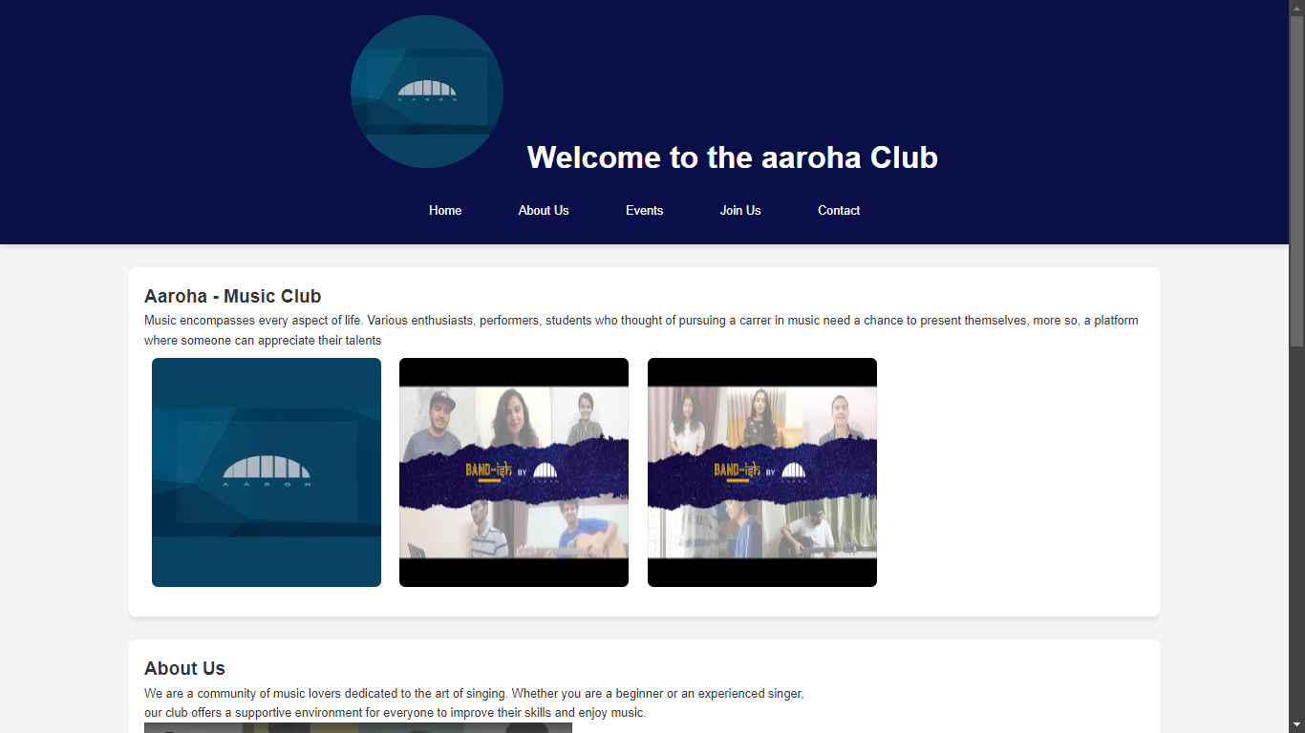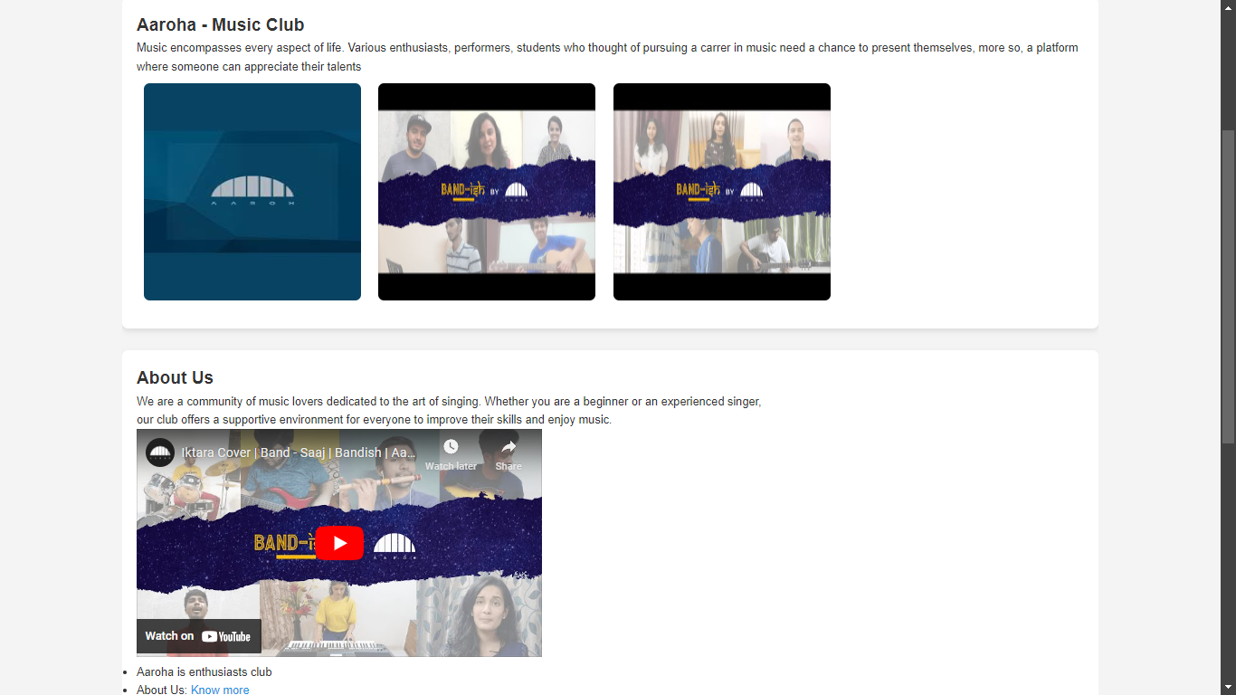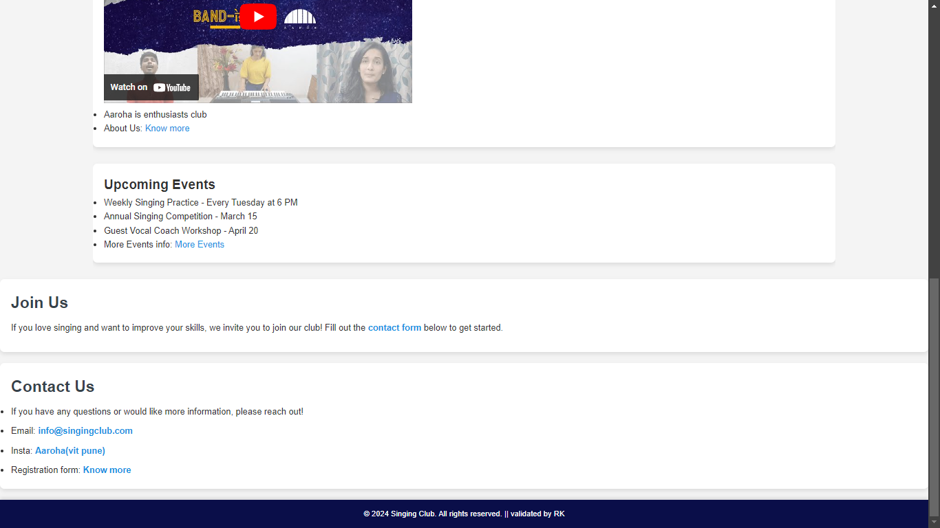

ABOUT US

<!DOCTYPE html>

<html lang="en">

<head>

<meta charset="UTF-8">

<meta name="viewport" content="width=device-width, initial-scale=1.0">

<title>Aaroha</title>

<style>

* {

margin: 0;

padding: 0;

box-sizing: border-box;

}

body {

font-family: Arial, sans-serif;

line-height: 1.6;

background-color: #f4f4f4;

color: #333;

}

header {

background-color: #0a0e49;

color: #fff;

text-align: center;

padding: 20px 0;

box-shadow: 0 4px 6px rgba(0, 0, 0, 0.1);

}

header h1 {

font-size: 2.5rem;

margin-bottom: 10px;

}

header img {

border-radius: 50%;

margin-right: 20px;

}

nav {

margin-top: 15px;

}

nav a {

color: #fff;

text-decoration: none;

margin: 0 15px;

font-size: 16px;

padding: 10px 20px;

display: inline-block;

border-radius: 4px;

transition: background-color 0.3s ease;

}

nav a:hover {

background-color: #6327c4;

}

.container {

width: 80%;

margin: auto;

overflow: hidden;

padding-top: 30px;

}

.content {

background-color: #fff;

padding: 20px;

margin-bottom: 30px;

border-radius: 8px;

box-shadow: 0 4px 8px rgba(0, 0, 0, 0.1);

}

.content img {

width: 100%;

max-width: 300px;

margin: 10px;

display: inline-block;

border-radius: 8px;

}

footer {

background-color: #0a0e49;

color: #fff;

text-align: center;

padding: 15px 0;

position: static;

bottom: 0;

width: 100%;

font-size: 14px;

box-shadow: 0 -4px 6px rgba(0, 0, 0, 0.1);

}

a {

color: #1493e2;

text-decoration: none;

}

a:hover {

text-decoration: underline;

color: #4532ad;

}

.ending .content {

margin-bottom: 20px;

}

.ending h3 {

margin-bottom: 10px;

font-size: 1.8rem;

color: #35424a;

}

.ending p {

font-size: 1rem;

color: #333;

margin-bottom: 10px;

}

.ending a {

font-weight: bold;

}

@media (max-width: 768px) {

header h1 {

font-size: 2rem;

}

.container {

width: 90%;

}

nav a {

display: block;

margin: 10px 0;

}

.content img {

max-width: 100%;

margin: 10px 0;

}

footer {

font-size: 12px;

}

}

</style>

</head>

<body>

<header>

<h1><img src="https://encrypted-tbn0.gstatic.com/images?q=tbn:ANd9GcRQ_VdLkRJ7tND6d7Q0t0uarDADzCgHAO5u1Q&s" alt="This is club logo" width="200px" height="200px" > Welcome to the aaroha Club</h1>

<nav>

<a href="http://127.0.0.1:5500/web%20Development/web%20page%20assignment.html">Home</a>

<a href="http://127.0.0.1:5500/web%20Development/Web%20Developmet%20About%20us.html">About Us</a>

<a href="http://127.0.0.1:5500/web%20Development/Web%20Development%20assignmenet%20events.html">Events</a>

<a href="#join">Join Us</a>

<a href="#contact">Contact</a>

</nav>

</header>

<div class="container">

<div class="content" id="about">

<h2>About Us</h2>

<p>We are a community of music lovers dedicated to the art of singing. Whether you are a beginner or an experienced singer,<br> our club offers a supportive environment for everyone to improve their skills and enjoy music.</p>

<br>

<p>Aaroha is the official music club at VIT Pune, designed for students passionate about music, whether they are singers, instrumentalists, or just music enthusiasts. The club offers a platform for students to showcase their musical talents, participate in events, and collaborate with fellow musicians. <br> <br>

Aaroha often organizes a variety of activities, including: <br>

- **Live performances**: Concerts, jam sessions, and open mics. <br>

- **Competitions**: Inter-college and intra-college music competitions. <br>

- **Workshops**: Music workshops to enhance skills in vocals, instruments, or music production. <br> <br>

If you're interested in joining, the club likely holds auditions or open registrations at the beginning of the academic year. It’s a great space to connect with like-minded students and grow your passion for music!</p>

<br>

<p><iframe src="https://www.youtube.com/embed/PLvWw88efz4?si=8h6gn46Ce5sbl9LI" width="560" height="315" title="YouTube video player" frameborder="0" accelerometer; autoplay; clipboard-write; encrypted-media; gyroscope; picture-in-picture; web-share" referrerpolicy="strict-origin-when-cross-origin" allowfullscreen></iframe></p>

</div>

</div>

<div class="ending">

<div class="content" id="join">

<h3>Join Us</h3>

<p>If you love singing and want to improve your skills, we invite you to join our club! Fill out the <a href="#contact">contact form</a> below to get started.</p>

</div>

<div class="content" id="contact">

<h3>Contact Us</h3>

<p>If you have any questions or would like more information, please reach out!</p>

<p>Email: <a href="mailto:info@singingclub.com">info@singingclub.com</a></p>

<p>Insta: <a href="https://www.instagram.com/vit_aaroh/" target="_blank"> Aaroha(vit pune)</a></p>

</div>

</div>

<footer>

<p>&copy; 2024 Singing Club. All rights reserved. || validated by RK</p>

</footer>

</body>

</html>

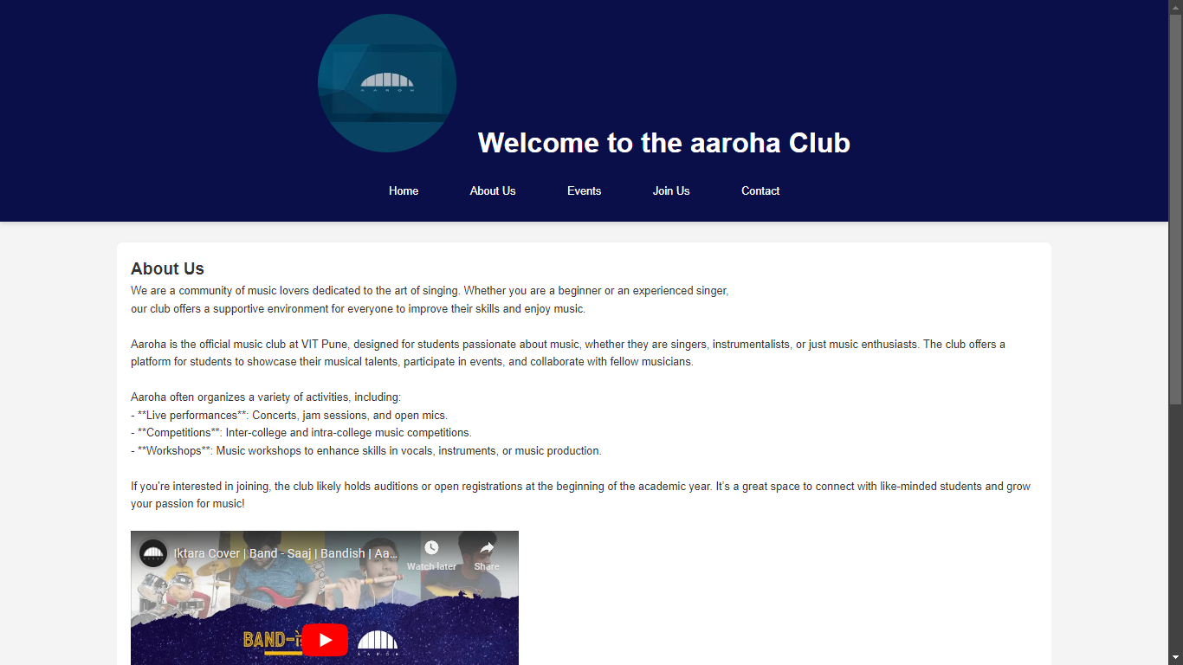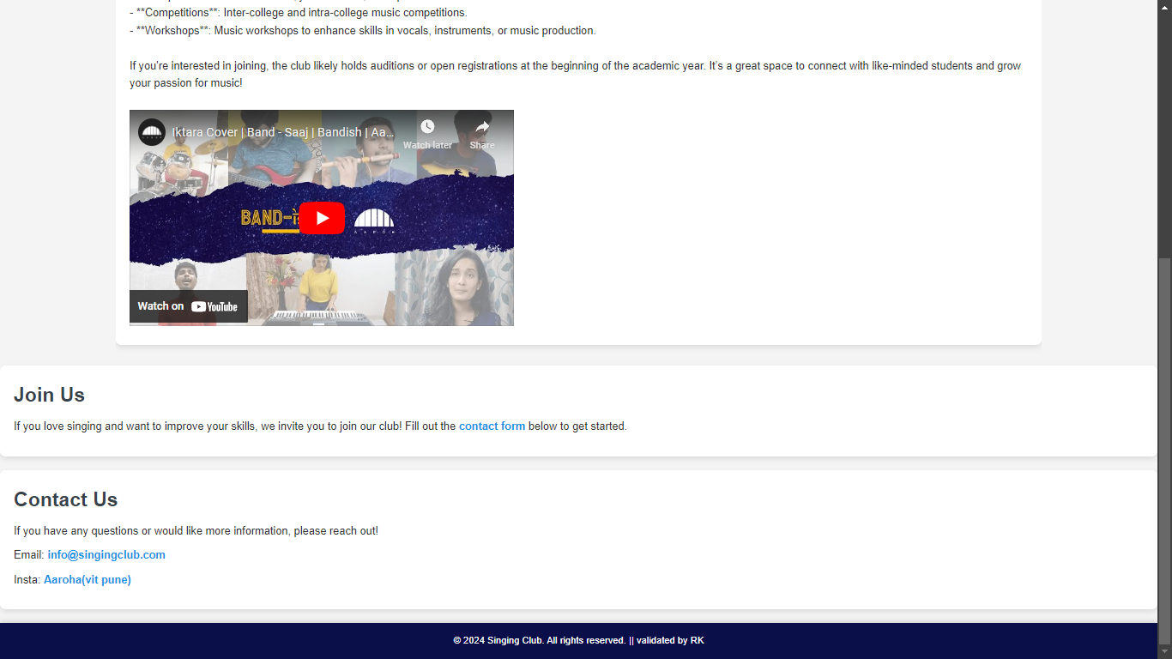

EVENT PAGE

<!DOCTYPE html>

<html lang="en">

<head>

<meta charset="UTF-8">

<meta name="viewport" content="width=device-width, initial-scale=1.0">

<title>Aaroha</title>

<style>

* {

margin: 0;

padding: 0;

box-sizing: border-box;

}

body {

font-family: Arial, sans-serif;

line-height: 1.6;

background-color: #f4f4f4;

color: #333;

}

header {

background-color: #0a0e49;

color: #fff;

text-align: center;

padding: 20px 0;

box-shadow: 0 4px 6px rgba(0, 0, 0, 0.1);

}

header h1 {

font-size: 2.5rem;

margin-bottom: 10px;

}

header img {

border-radius: 50%;

margin-right: 20px;

}

nav {

margin-top: 15px;

}

nav a {

color: #fff;

text-decoration: none;

margin: 0 15px;

font-size: 16px;

padding: 10px 20px;

display: inline-block;

border-radius: 4px;

transition: background-color 0.3s ease;

}

nav a:hover {

background-color: #45a049;

}

.container {

width: 80%;

margin: auto;

overflow: hidden;

padding-top: 30px;

}

.content {

background-color: #fff;

padding: 20px;

margin-bottom: 30px;

border-radius: 8px;

box-shadow: 0 4px 8px rgba(0, 0, 0, 0.1);

}

.content img {

width: 100%;

max-width: 300px;

margin: 10px;

display: inline-block;

border-radius: 8px;

}

footer {

background-color: #0a0e49;

color: #fff;

text-align: center;

padding: 15px 0;

position: static;

bottom: 0;

width: 100%;

font-size: 14px;

box-shadow: 0 -4px 6px rgba(0, 0, 0, 0.1);

}

a {

color: #1493e2;

text-decoration: none;

}

a:hover {

text-decoration: underline;

color: #2d247a;

}

.ending .content {

margin-bottom: 20px;

}

.ending h3 {

margin-bottom: 10px;

font-size: 1.8rem;

color: #35424a;

}

.ending p {

font-size: 1rem;

color: #333;

margin-bottom: 10px;

}

.ending a {

font-weight: bold;

}

@media (max-width: 768px) {

header h1 {

font-size: 2rem;

}

.container {

width: 90%;

}

nav a {

display: block;

margin: 10px 0;

}

.content img {

max-width: 100%;

margin: 10px 0;

}

footer {

font-size: 12px;

}

}

</style>

</head>

<body>

<header>

<h1><img src="https://encrypted-tbn0.gstatic.com/images?q=tbn:ANd9GcRQ_VdLkRJ7tND6d7Q0t0uarDADzCgHAO5u1Q&s" alt="This is club logo" width="200px" height="200px" > Welcome to the aaroha Club</h1>

<nav>

<a href="http://127.0.0.1:5500/web%20Development/web%20page%20assignment.html">Home</a>

<a href="http://127.0.0.1:5500/web%20Development/Web%20Developmet%20About%20us.html">About Us</a>

<a href="http://127.0.0.1:5500/web%20Development/Web%20Development%20assignmenet%20events.html">Events</a>

<a href="#join">Join Us</a>

<a href="#contact">Contact</a>

</nav>

</header>

<div class="container">

<div class="content" id="info">

<h2>Events within Aaroha</h2>

<p>Music encompasses every aspect of life. Various enthusiasts, performers, students who thought of pursuing a carrer in music need a chance to present themselves, more so, a platform where someone can appreciate their talents</p>

<br>

<p>Aaroha Music Club at VIT Pune is known for organizing a variety of events throughout the academic year that cater to different aspects of musical expression. Here are some more events they typically organize: <br> <br>

1. **Annual Cultural Fest Performances**: <br>

- Aaroha plays a big part in VIT Pune’s cultural fest, **Melange**. They organize band performances, solo acts, and group performances during the fest, featuring different music genres. <br> <br>

2. **Jamming Sessions**: <br>

- These informal meetups allow members to collaborate, explore new music styles, and experiment with improvisation. It’s a great way for beginners and experienced musicians alike to bond and improve their skills. <br> <br>

3. **Battle of the Bands**: <br>

- A competitive event where various student bands from within and outside VIT Pune battle it out for the title of the best band. It's a high-energy event, with each band bringing their best music to the stage. <br> <br>

4. **Unplugged Nights**: <br>

- These are acoustic music nights where musicians perform unplugged versions of songs. It’s a more relaxed and intimate event, often set in an outdoor venue. <br> <br>

5. **Tribute Nights**: <br>

- Themed events dedicated to legendary artists or bands where members perform covers of iconic songs. Past tributes might have included artists like The Beatles, Queen, or A.R. Rahman. <br> <br>

6. **Music Production Workshops**: <br>

- Workshops where experts in music production teach students how to create their own music using software like FL Studio, Ableton, or Logic Pro. It’s a fantastic learning experience for those interested in the technical side of music. <br> <br>

7. **Open Mic Events**: <br>

- A platform where anyone, not just club members, can perform. These events are typically casual and invite performances from singers, poets, and instrumentalists. <br> <br>

8. **Collaborations with Other Clubs**: <br>

- Aaroha collaborates with other cultural clubs, like the dance or drama clubs, to provide live music for performances. This synergy creates a rich cultural experience during major college events. <br> <br>

These events are great opportunities for students to showcase their talent, learn, and make connections within the music scene at VIT Pune.</p>

<img src="https://encrypted-tbn0.gstatic.com/images?q=tbn:ANd9GcRQ_VdLkRJ7tND6d7Q0t0uarDADzCgHAO5u1Q&s" alt="this is a image of aaroha" width="33%" height="300px">

<img src="https://i.ytimg.com/vi/vZdWJ_jIKsI/hqdefault.jpg" alt="" width="33%" height="300px">

<img src="https://i.ytimg.com/vi/OtHNsC8fKkY/hqdefault.jpg" alt="" width="33%" height="300px">

</div>

</div>

<div class="ending">

<div class="content" id="join">

<h3>Join Us</h3>

<p>If you love singing and want to improve your skills, we invite you to join our club! Fill out the <a href="#contact">contact form</a> below to get started.</p>

</div>

<div class="content" id="contact">

<h3>Contact Us</h3>

<p>If you have any questions or would like more information, please reach out!</p>

<p>Email: <a href="mailto:info@singingclub.com">info@singingclub.com</a></p>

<p>Insta: <a href="https://www.instagram.com/vit_aaroh/" target="_blank"> Aaroha(vit pune)</a></p>

</div>

</div>

<footer>

<p>&copy; 2024 Singing Club. All rights reserved. || validated by RK</p>

</footer>

</body>

</html>

